Selective-Reject Program Design

Cody Jones
CPE 464
2/26/2015

Question 1.
For all of the packet flow diagrams, the window size is 3, and there are 6 data packets total.

a) No Packets Lost

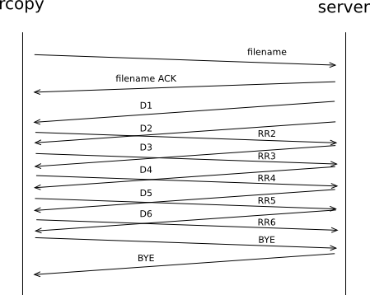

b) One Packet Lost

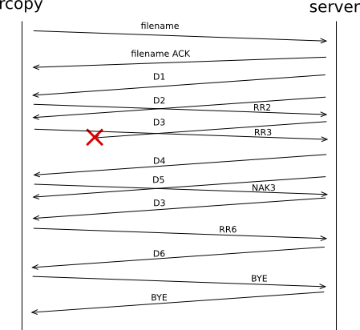

Notes
- Receive an unexpected (out of order) packet D4.
- Respond with NAK3
- Wait for D3.
- Buffer any other packets that arrive.

c) Multiple Packets Lost (Sequential)

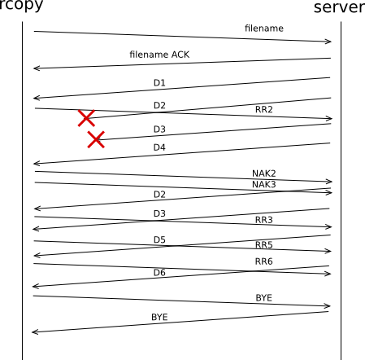

Notes
- 2 Packets are dropped
- Respond with a NAK for each packet.
- Wait for both missing packets to arrive.
- Buffer any other packets in the mean time.

c) Multiple Packets Lost (Not Sequential)

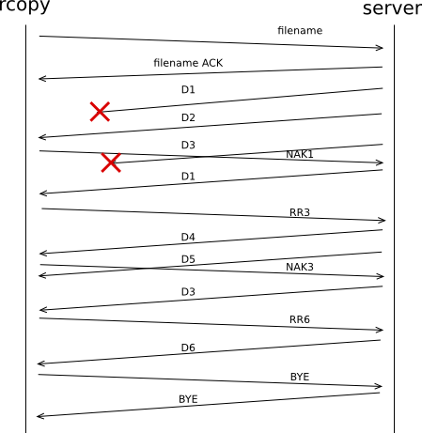

Notes

d) RR Lost

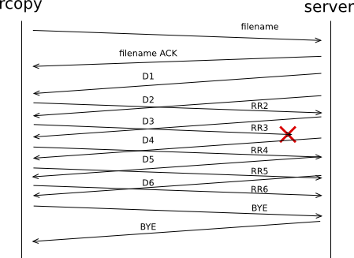

e) Multiple RRs Lost
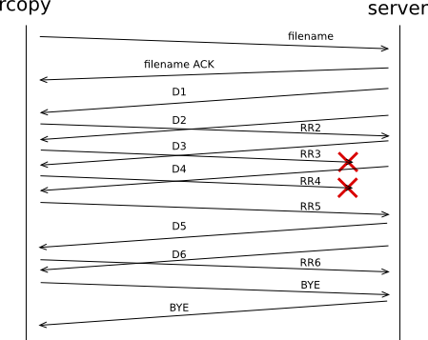

f) NAK Lost

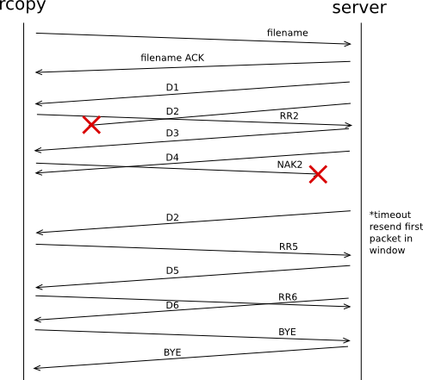

g) Entire Window of Data Lost

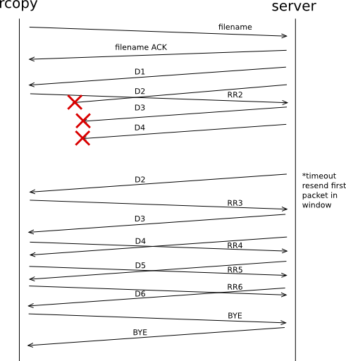

h) Entire Window of RRs Lost

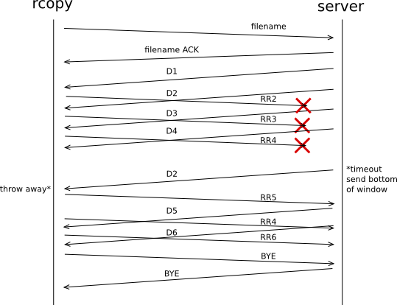

Question 2

What can cause the window to close?

If no packets are lost, the window can close if transmission is slow or the window is too small.
If one or more data packet(s) is lost, the window can close. When the NAK for the packet(s) arrives, the lost data packet(s) should be sent again.
If a NAK is lost, the window will close. The server will timeout. On timeout the server should send the earliest packet in the window. This packet will be the one for the missing NAK.
If an entire window of RRs is lost, the window will close. The server will timeout and resend the earliest packet in the window. This will prompt the client to resend the highest RR.

Question 3

The blocking (timed) select may only timeout if:
A NAK is lost.
An entire window of data is lost.
An entire window of RRs is lost.

Question 4

How do the following occur and what action should be taken?
a) A data frame number is a duplicate of one you have already received.
This may occur after a timeout. The server will send the earliest packet in its window, which the client may already have received. The client should ignore the packet, and RR or NAK as appropriate.
b) A data frame number is greater than the one you expected but is still in your window size.
This will occur if a data packet is lost. The client should add the received data frame to its buffer, and NAK the implicitly lost packet.
c) A data frame number is the one you are expecting but you have already received frames with higher numbers.
This will happen once the client receives a packet which it requested with a NAK. The client should flush the its buffer to disk (only up to the next highest missing data packet if there is one).

Question 5
Scenario: Client receives frames 1, 2, 3, 4, 5, and the 7 and 8, and then 10, 11, and 12.
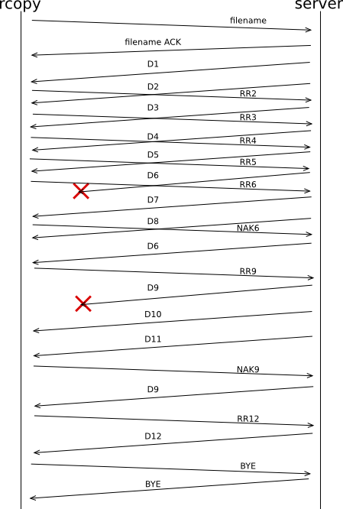
The first issue comes when data packet 6 is lost. The client sends NAK6 and buffers packets 7 and 8 when they arrive. When the client receives packet 6, all three packets are written to disk and the client sends RR9. Packet 9 is lost which is recovered from by the same algorithm.

Question 6

Scenario A

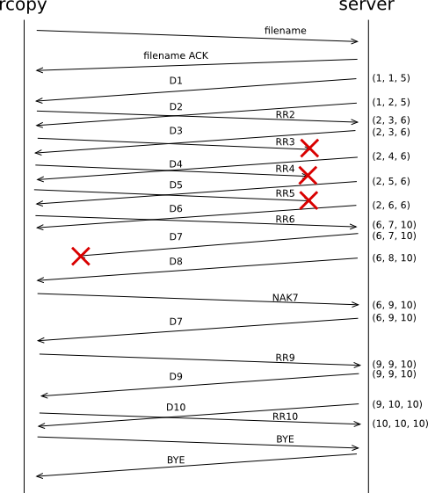

Scenario A

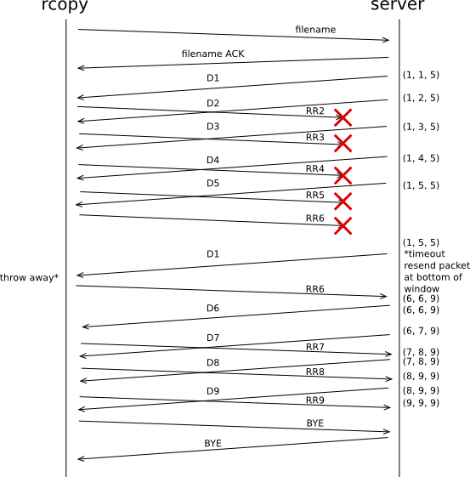

Scenario C

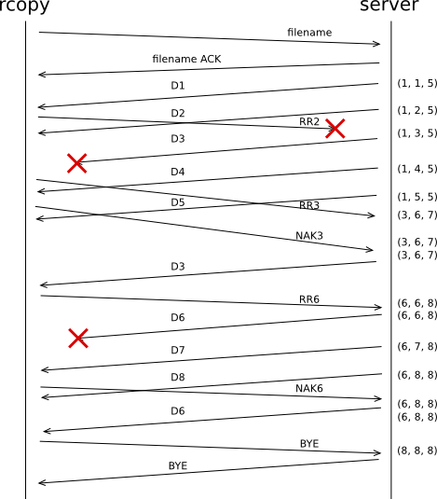

Question 7

A) No Packets Lost

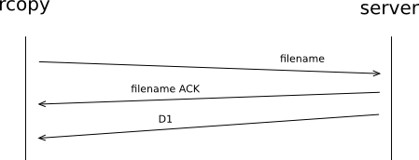

B) Filename Packet Lost

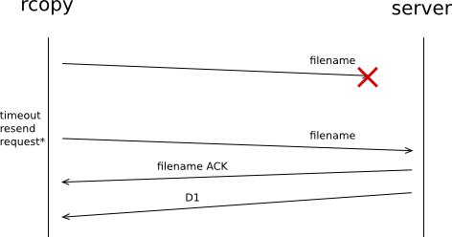

C) Second Packet Sent by Client Lost

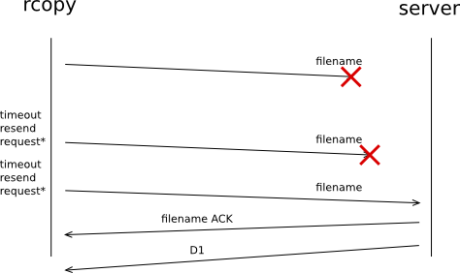

D) Filename ACK Lost

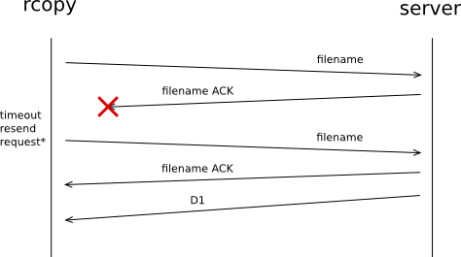

E) First 2 Packets from Server Lost

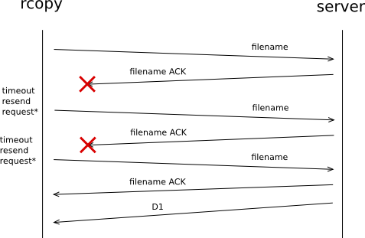

F) Entire Last Data Packet Window Lost

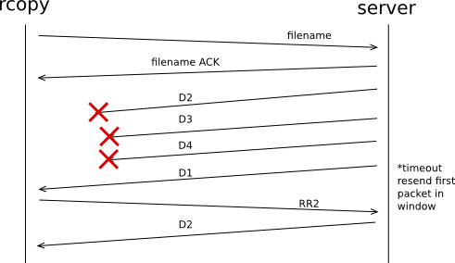

F) Entire Last RR Packet Window Lost

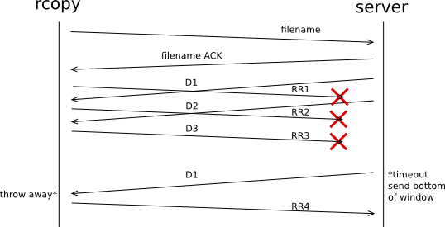

Question 8

A) Last Data Packet Lost

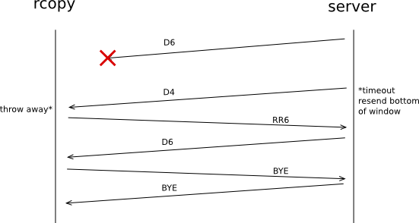

B) ACK For Last Data Packet Lost

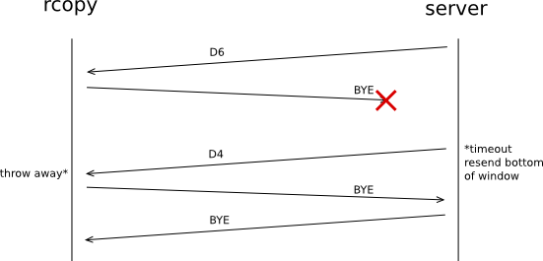

C) 2nd and 5th To Last Data Packets Lost

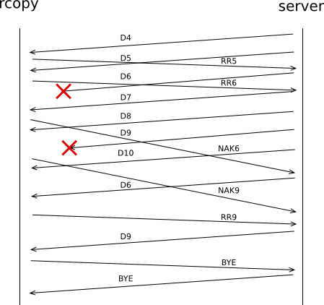

Part II: State Diagrams

